**Digital Forensics Lab Report: 5**

Date: 24-08-2022

| Name: | Vedant H. Patel |
| --- | --- |
| Roll No: | 19BCP138 |
| Subject Code: | 20CP411P |
| Subject Name: | Digital Forensics Lab |

**Aim/Purpose:** Explore Fake news detection using different tools.

**Tool Names:** Google image search,Tineye image search, YouTube data viewer, Foto forensic, Forensically, Pic2map, Suncalc, Wikimapia, Exif Data Viewer, Jeffrey exif viewer, Exiftool, Metagoofil, YouTube metadata.

**Tool 1:- Suncalc**

**Steps:**

1. Open <https://www.suncalc.org/#/49.2334,19.4414,3/2022.08.18/10:43/1/3>
2. Now select the location by moving the pin on map or you can also type the description of that location on the left side text box and press enter
3. Then you will get a geographical map view of that location in center
4. And left side you will get solar data or geodata of that location.

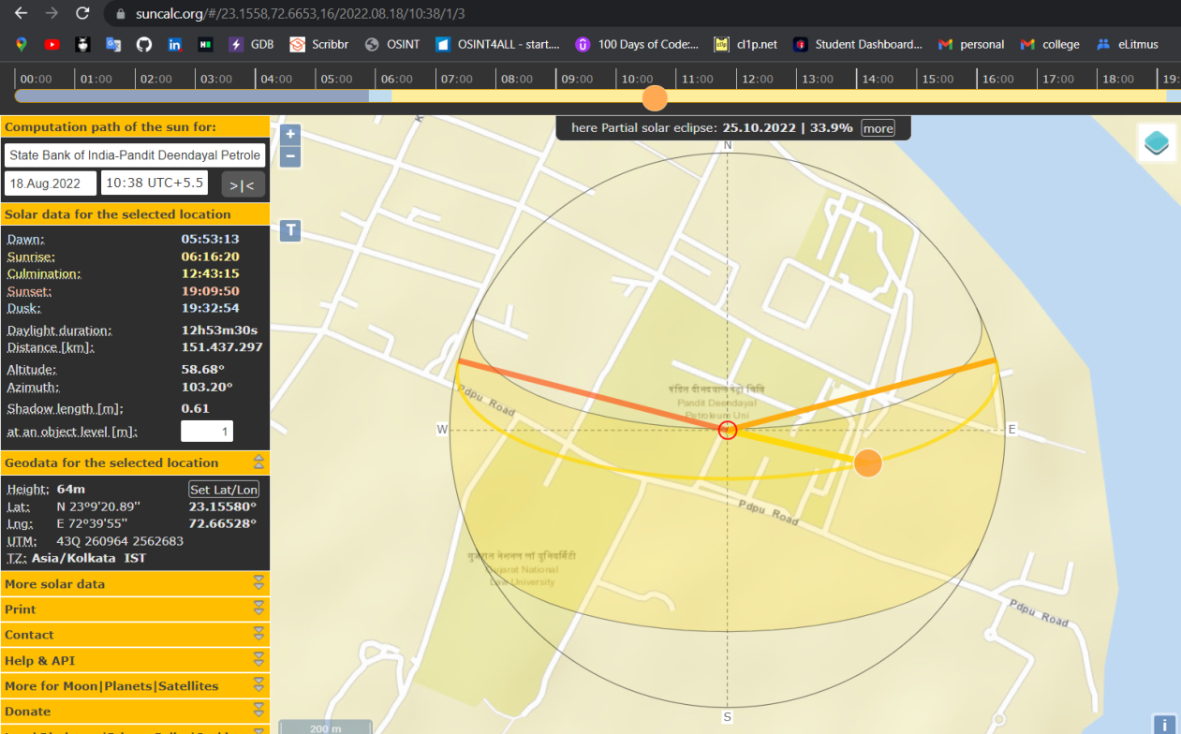

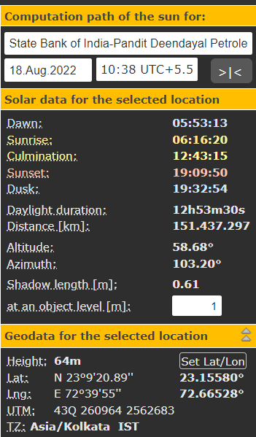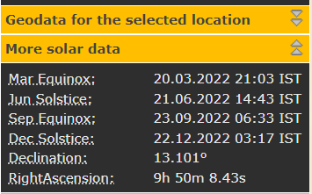

**Analysis:-**

You will get sunrise, sunset, Dusk, daylight duration and other information by its location description. And if you do not know the location description properly then you can go for map option and you can select the location from map.

**Tool 2:- Wikimapia**

**Steps:-**

1. Open <https://wikimapia.org/>
2. There is search bar on right topmost corner in that you can search anything that you want to search like Stadium, Shops, parks, Schools, etc.
3. In right Side you will all location of that query. Ex:- if you search stadium then you will get all stadium in geographical map.
4. Select the points one by one you will get the stadium details on the left side of page.

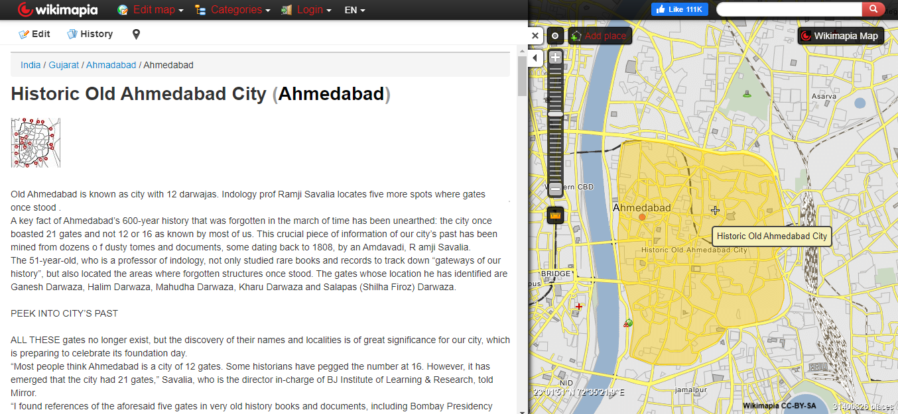

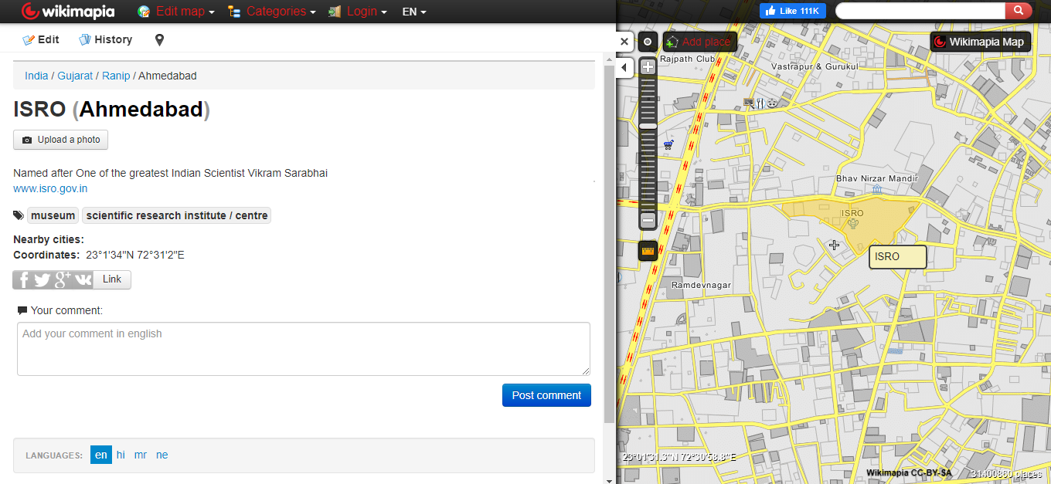

**Analysis:-**

You will get the all locations of particular place by just its type name. Ex:- if want to know about the all shops of your city then just select the city and set the scale to city scan and press enter then you will get the all shops location and its available details.

**Tool 3:- Exif Data Viewer**

**Steps:-**

1. Open <https://exifdata.com/>
2. Press on the choose File for selecting the file from local machine and select the file and upload it
3. Also there is a option for image url if you want fetch details and summary by any online image
4. Press on “Submit” button
5. Then you will get summary and detailed of uploaded images

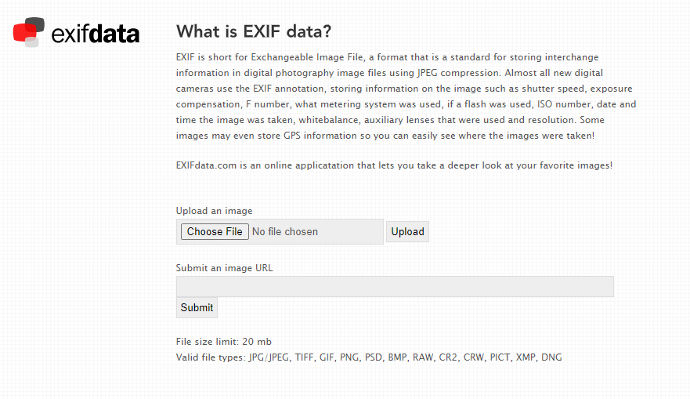

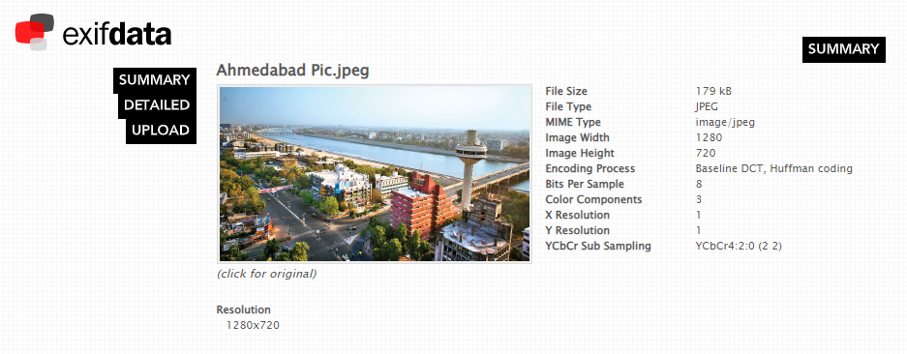

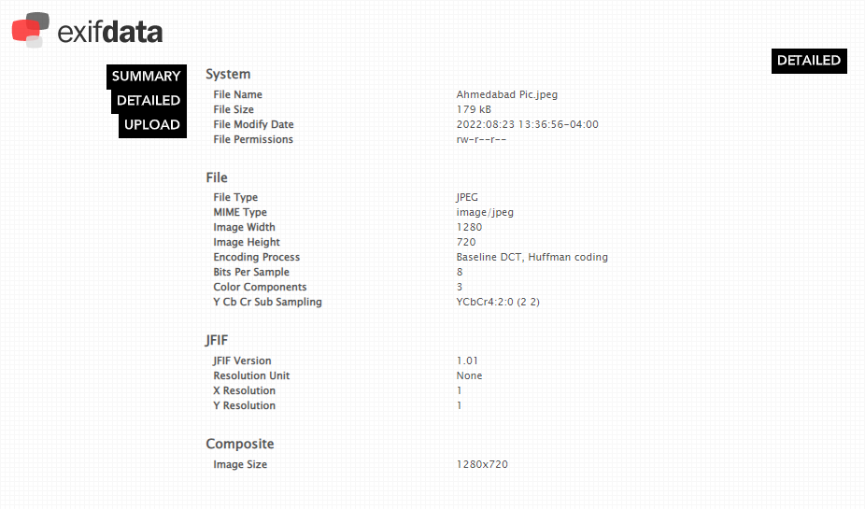

**Analysis:-**

You will get the file size, image width, or JFIF details of the images.

**Tool 3:- Jeffrey exif viewer**

**Steps:-**

1. Open <https://exifdata.com/>
2. Press on the choose File for selecting the file from local machine and select the file and upload it
3. Also there is a option for image url if you want fetch details and summary by any online image
4. Press on “Submit” button

**Tool 4:- Exif Viewer**

**Steps:-**

1. Open <http://exif-viewer.com/>
2. Press on the choose File for selecting the file from local machine and select the file and upload it
3. Also there is a option for image url if you want fetch details and summary by any online image
4. Press on “Submit” button

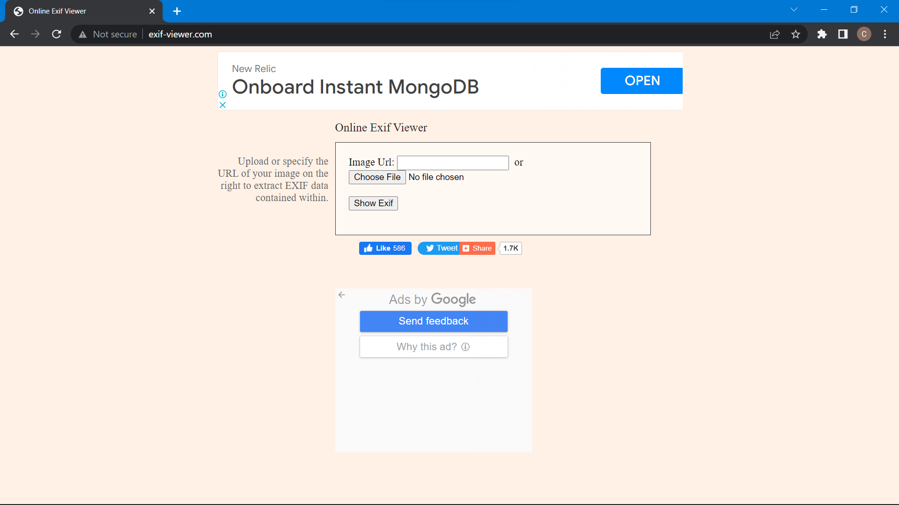

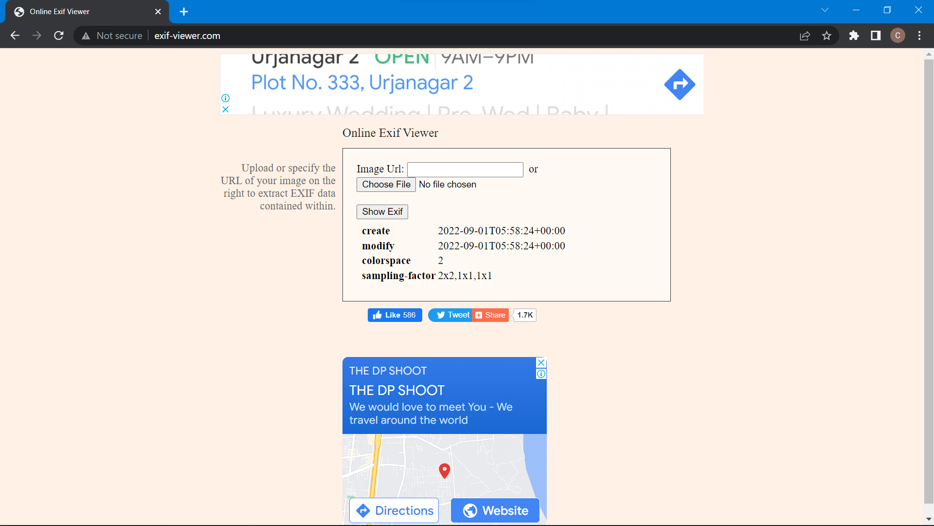

**Tool 5:- Online OCR**

**Steps:-**

1. Go to [Online OCR](https://www.onlineocr.net/)
2. One can convert images to text here.
3. There are various other services available as well.

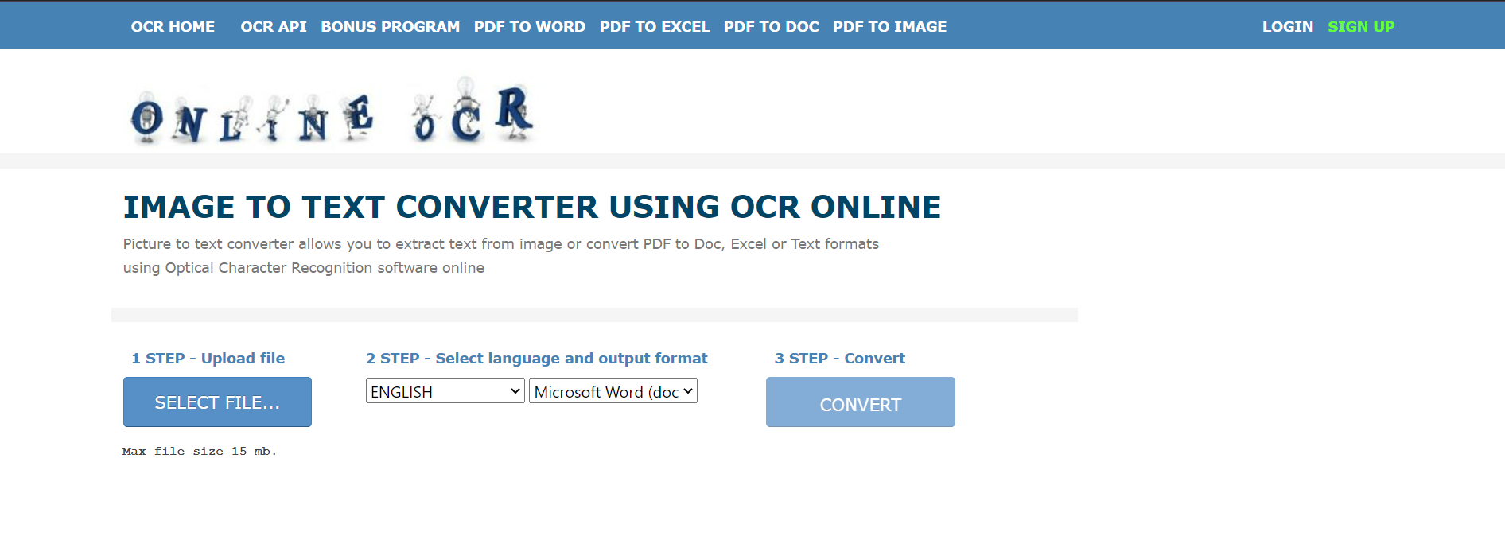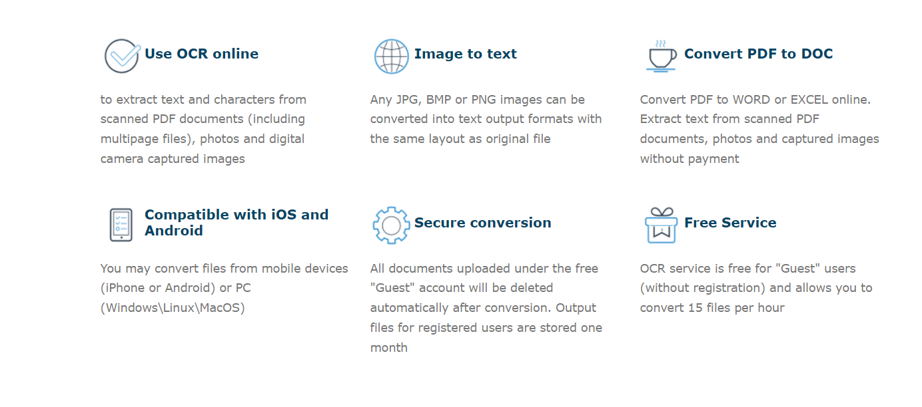

**Tool 6:- Metagoofil**

The **Metagoofil** is an information-gathering tool. This is a free and open-source tool designed to extract all the metadata information from public documents that are available on websites. This tool uses two libraries to extract data. These are Hachoir and PdfMiner. After extracting all the data, this tool will generate a report which contains usernames, software versions, and servers or machine names that will help Penetration testers in the information-gathering phase.

**Steps:-**

1. Open your kali Linux operating system and install the tool using the following command.
2. git clone https://github.com/laramies/metagoofil.git

cd metagoofil

1. python metagoofil.py
2. Use the metagoofil tool to extract PDFs from a website.
3. python metagoofil.py -d flipkart.com -l 100 -n 5 -t pdf -o newflipkart.

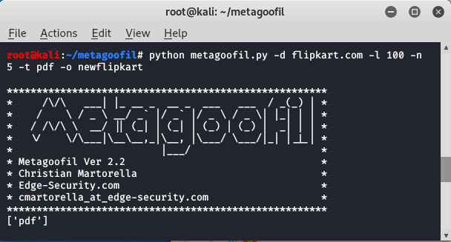

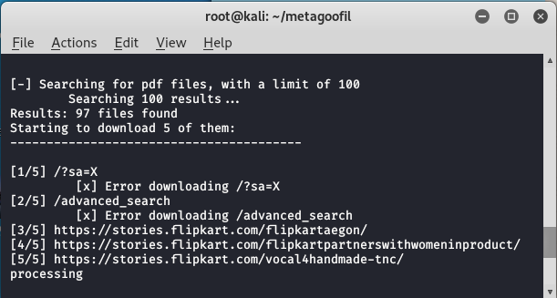

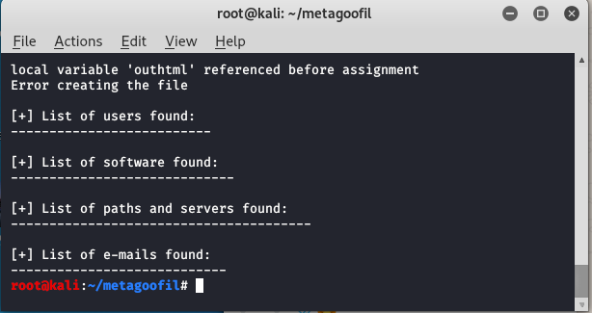

In this way, you can extract PDFsf and information on files from a website.

**Tool 7:- Google Earth**

**Steps:-**

1. Go to [Google Earth](https://google-earth-online.gosur.com/)
2. Explore the website

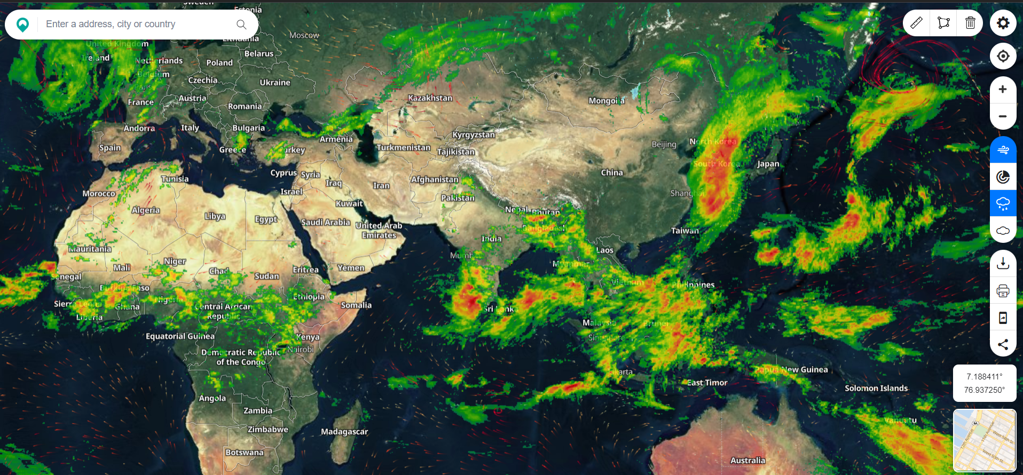

**Tool 8:- EXIF Viewer**

**Steps:-**

1. Go to [EXIF](https://onlineexifviewer.com/)
2. Upload your image
3. Get the exif data

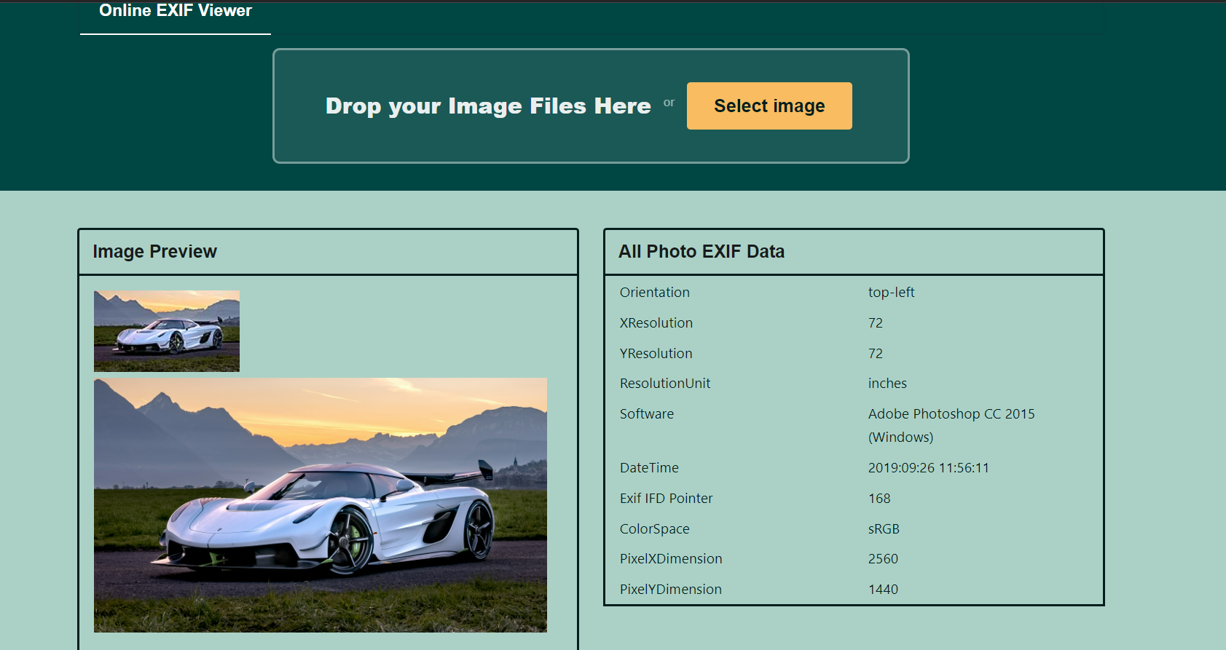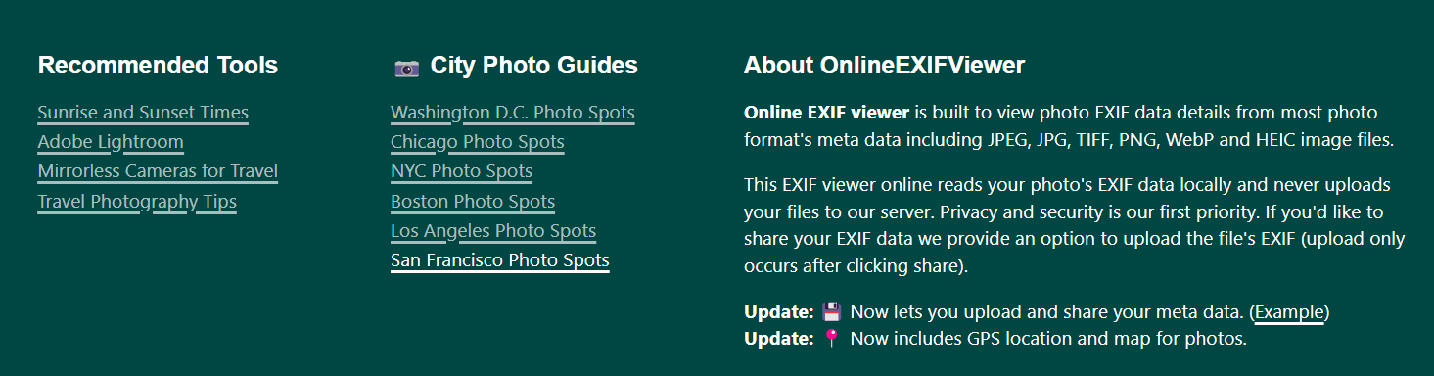

**Tool 9:- Internet Archive Videos**

**Steps:-**

1. Go to [Internet archive](https://archive.org/details/opensource_movies?&sort=-week&page=2)
2. Here you can get access to any images and videos uploaded by the community.

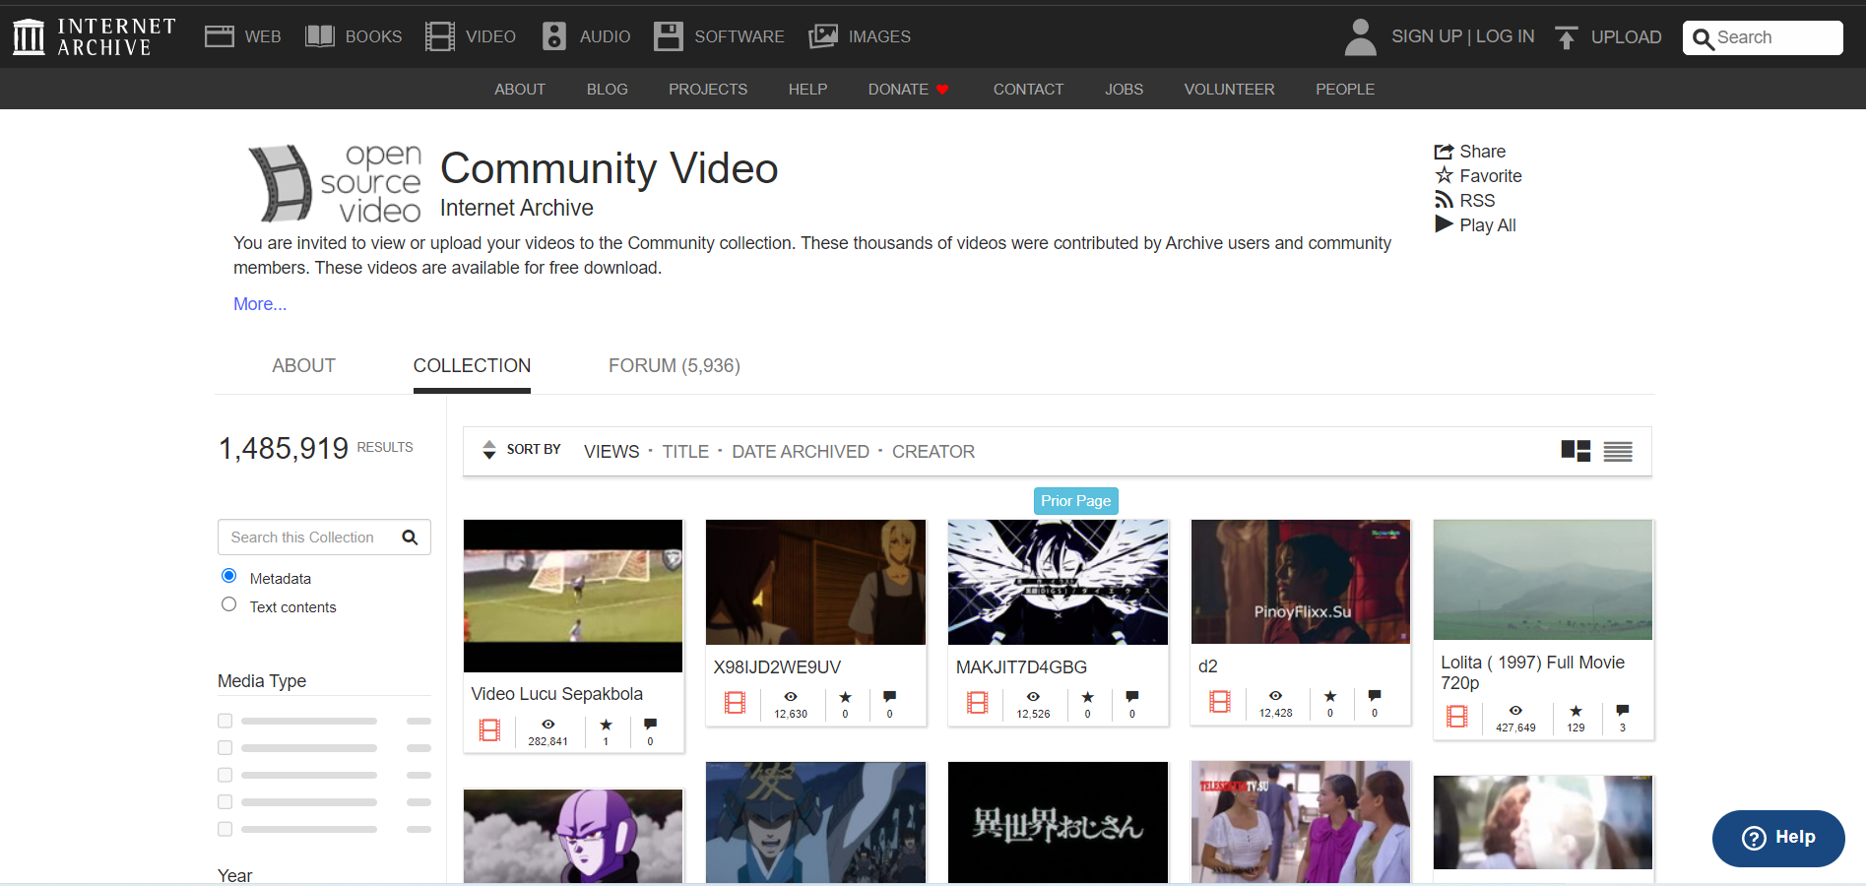

**Tool 10:- Forensically**

**Steps:-**

1. Open <https://29a.ch/photo-forensics/#forensic-magnifier>
2. Press on the open File for selecting the file from the local machine and select the file and upload it.
3. Also there is an option for image url if you want fetch details and summary by any online image.

